horizontal line

App Review Filter - JS Assignment

# OVERVIEW

In this assignment, we have to create a search filter for app reviews. You can think of this just like the search experience you have on flipkart, amazon or myntra for various kinds of products on these websites. Similar to these, we will have a list of app reviews (crawled from various sources and saved to database) exposed as a JSON. We have to build UI/website for search interface over these app reviews.

# GOAL/SCOPE

1. Create a web interface for searching app reviews using React JS, HTML and CSS.
2. Dummy review data for 1500 reviews is provided as JSON. This exact data has to be used on the client side to build a working prototype. (use dummy JSON).
3. API integration is not in scope of this assignment.
4. Backend/server side implementation is not in scope of this assignment.

# REVIEW ATTRIBUTES

|  |  |
| --- | --- |
| **Review attribute** | **Attribute Details** |
| ID | ID of review |
| AppID | App id for the app |
| AppStoreName | Google playstore / Apple appstore |
| ReviewDate | Date on which review was submitted |
| Rating | Rating given along with review out of 5 |
| Version | Version of app for which review was given |
| CountryName | Name of country from which review was given |
| ReviewHeading | Heading of review |
| ReviewText | Test of review |
| ReviewUserName | Name of user who provided the review |

# 

# DESIGN

1. UI of the application should be exactly like below design, when in full page mode
2. On scrolling, left side filter options pane should stay fixed, while the reviews on right side should continue to scroll down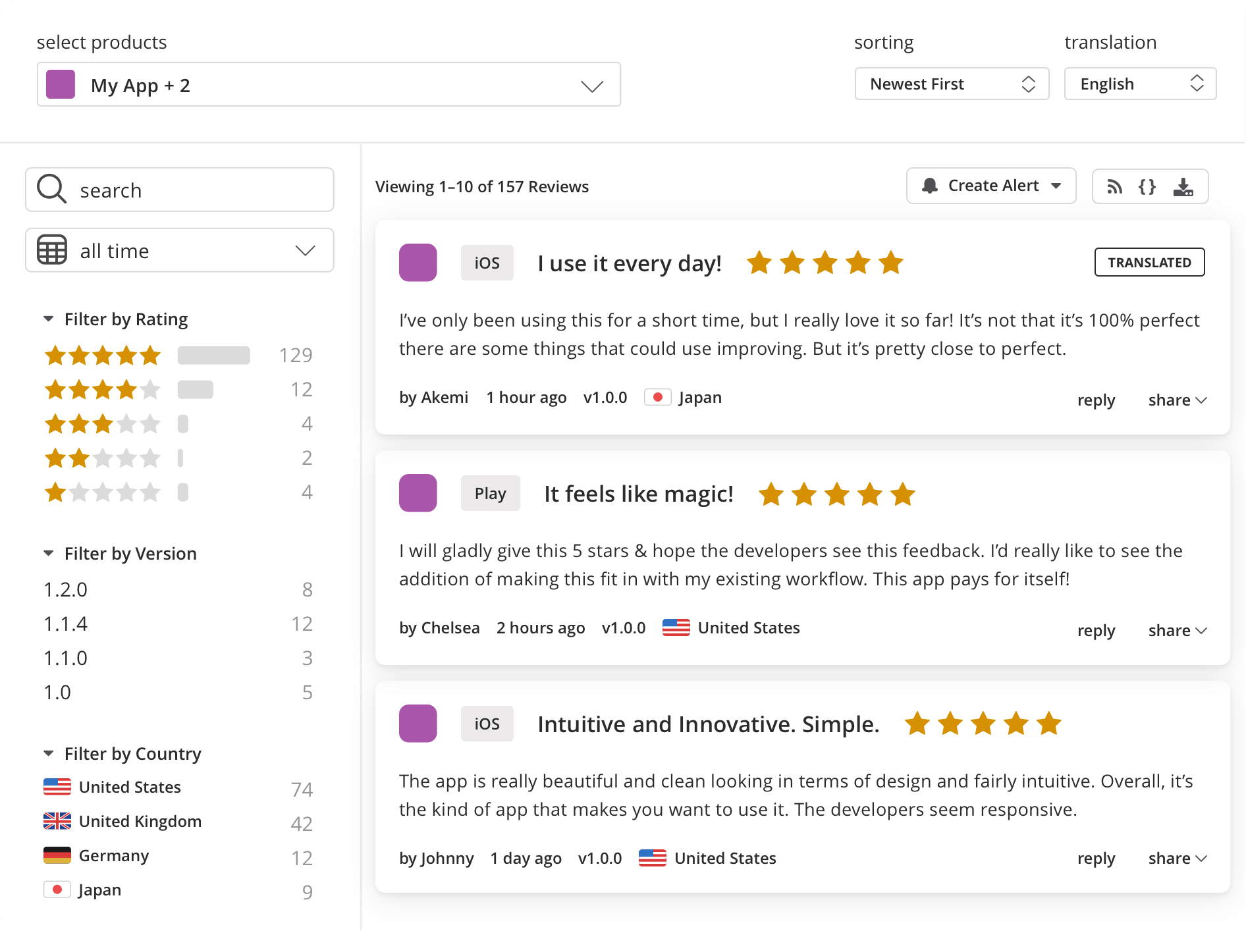
3. On bottom of page there should be a pagination bar with links to page 1, 2, 3 etc,. Clicking on these, should take user to reviews on the appropriate page.
4. Ignore reply, share, translation, create alert and download functionality in the above design. These are not to be built for this assignment.

# 

# 

# FEATURES

## APP SELECTION DROPDOWN

1. A user can have multiple apps in his accounts. User can change the app for which reviews are seen from “selects products” dropdown. All apps of user will be available in this drop down. By default first app, in alphabetical order, will be selected.
2. On first load of webpage, all reviews along with relevant filters will show up, sorted by newest review first, for the app selected in “select products” dropdown.
3. User should be able to, change an app for which reviews are shown by changing the value from “select products” dropdown. Once changed, review for selected app will be shown.

## SORTING

1. User should be able to sort reviews based on 2 criterias
   1. Newest first
   2. Oldest first

## SEARCH FILTERS

1. User should be able to, filter the reviews for selected app based on following criteria
   1. Keyword search (Input box named Search on top left corner)
   2. Review Date (Time range selector populated to all-time by default)
   3. Ratings
      1. Count for reviews with a given rating are also shown along with an horizontal indicator for review count
      2. Clicking on a certain rating will show reviews only for that ratings
   4. Versions
      1. Count for reviews with for a given version are also shown
      2. Clicking on a certain version will show reviews only for that version
   5. Country
      1. Count for reviews with for a given country are also shown
      2. Clicking on a certain country will show reviews only for that country

## 

## 

## REVIEW DETAIL

1. For a review seen in search result, following details should be shown
   1. App store name - iOS/Play store
   2. Review Heading
   3. Review Rating
   4. Review Text
   5. Review User
   6. Review Time
   7. Review Country